Hackathon

Day-4- Completed

Furniro Ecommerce Template

Introduction:

Furniro Ecommerce is your go-to platform for shopping high-quality, stylish furniture online. It brings the furniture store to your fingertips, allowing you to browse and purchase your favorite pieces from the comfort of your home. No more wasting time in crowded showrooms or dealing with traffic—it’s all about convenience. Plus, Furniro connects small brands with a global audience, making it easier for them to showcase their products worldwide and grow their business.

Key Features:

* **Home Page**: A sleek and welcoming landing page that highlights featured furniture and top categories.
* **Shop Page**: An interactive product catalog with filters for price, furniture type, and category to make finding the perfect piece effortless.
* **Product Detail Page**: In-depth information about each product, including multiple images, detailed descriptions, and pricing.
* **Cart**: A user-friendly way to add, review, and manage selected items for checkout.
* **Checkout Page**: A smooth and intuitive process to complete your purchase securely.

Tech Stack:

* **Frontend**:
  + **Next.js**: Powers the application for fast performance and seamless navigation.
  + **HTML, CSS, TypeScript**: The building blocks for structure, design, and interactivity.
  + **React.js**: Ensures a modern and reusable component-based interface.
* **Styling**:
  + **Tailwind CSS**: Provides beautiful, responsive designs quickly with its utility-first approach.
* **Content Management**:
  + **Sanity CMS**: Simplifies the management of dynamic content, like product listings, categories, and orders
* **Shop:**

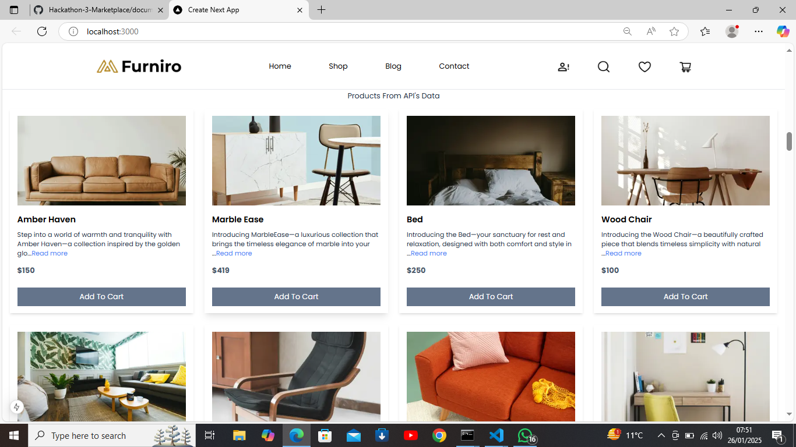

**Product Detail:**

##### 

**Shopping Cart:**

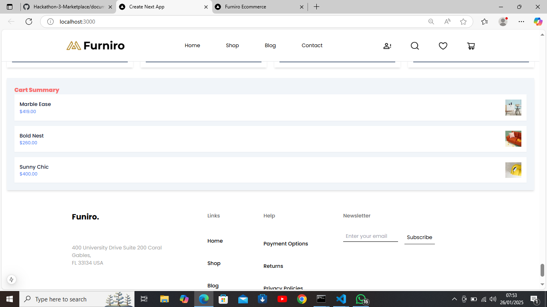

**Cart:**

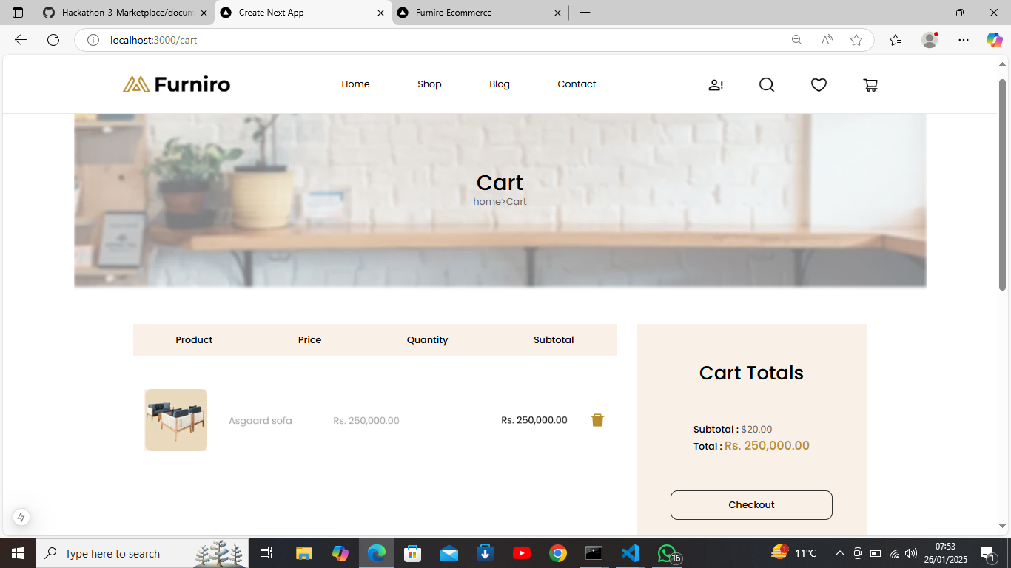

**CheckOut:**

# 

### **Final Thoughts**:

Furniro Ecommerce is designed to provide an effortless and enjoyable furniture shopping experience, blending sleek design with advanced functionality. From browsing to checkout, every step is tailored for convenience and customer satisfaction. Built with cutting-edge technologies like Next.js and Sanity CMS, the platform ensures dynamic content management and a responsive interface. It’s a win-win solution—making shopping easy for customers while helping furniture brands thrive in the competitive e-commerce space.